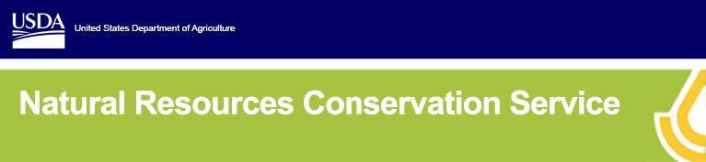

***Agricultural Conservation Easement Program Options***

# Overview:

The Wetland Reserve Easement (WRE) and Wetland Reserve Easement Partnership (WREP) are program options available through the USDA Natural Resources Conservation Service’s (NRCS) Agricultural Conservation Easement Program (ACEP). These options provide landowners a financial incentive to restore, protect, and enhance wetlands in exchange for placing marginal land into a conservation easement. The WREP option provides the flexibility to pass a pivot over the enrolled acres to maintain optimal irrigation of the surrounding cropland.

# Benefits:

* 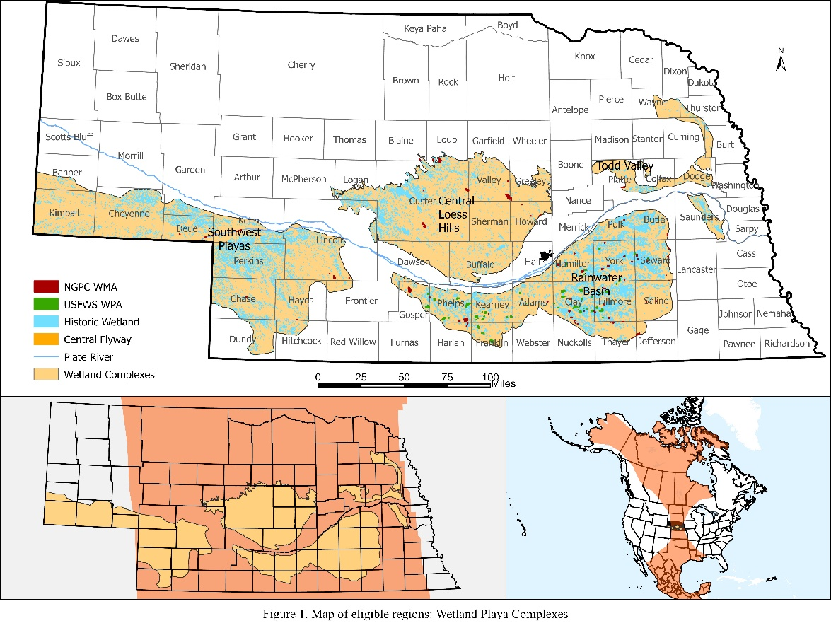Improve net farm income by transitioning flood-prone cropland to forage production and wildlife habitat;
* Financial and technical assistance for restoring and protecting wetlands. Partner cost-share for grazing infrastructure and/or pivot modifications to travel through the wetland;
* Maintain profitability by allowing pivots to cross wetlands to irrigate surrounding cropland or pasture not enrolled into WREP and receive assistance to improve irrigation efficiency on adjacent cropland;
* See a reduction in problems associated with farming wet areas; and
* Restored wetlands and grasslands provide unique wildlife habitat and can provide recreational opportunities on your land.

Wetlands benefit all Nebraskans by providing fish and wildlife habitat; improving water quality by filtering sediments and chemicals; reducing flooding; recharging the aquifer; and providing educational, scientific, and recreational activities.

# How ACEP Works:

The program offers three enrollment options:

1. **Permanent Easement.** Perpetual easement payment based on appraised value. Easement payment is up to 95% of the appraised value. 100% of restoration costs covered by NRCS.
2. **30-Year Easement.** Easement payment is 75% of permanent

easement value. NRCS pays 75% of restoration costs. Partner cost- share may be available for the remaining 25% of restoration costs.

1. **Reserved Grazing Rights.** Grazing rights retained with enrolled tract (permanent or 30- year option). There is a 25% payment reduction of the permanent or 30-year payment, as applicable. NRCS restoration costs-share same as described above for different easement length scenarios. Costs for grazing infrastructure may be available from partners.

Applications are accepted anytime. Landowners and Tribes can apply at their local NRCS field office.

Page 1

**INFORMATION BULLETIN**

**Agricultural Conservation Easement Program (ACEP)** April 2025

# Eligibility:

Playa wetlands – isolated depressions not associated rivers or streams located in Nebraska’s four Playas Wetland Complexes, (see map).

# Uses of Enrolled Land:

On all ACEP easements, the landowner controls access to the land and may lease the land for hunting, fishing, and other undeveloped recreational activities. At any time, a landowner may request additional activities. NRCS determines if they are compatible for the site. This request may include such items as permission to cut hay, graze livestock, or harvest wood products.

Compatible uses are allowed if they are consistent with the long-term protection and enhancement of the wetland. In the case of the Reserved Grazing Rights easement, landowners retain the right to graze the land with an approved grazing plan. With WREP the landowner retains the right to cross irrigation pivots through enrolled lands.

# For More Information:

**LEARN MORE**

Visit your local NRCS field office or scan the QR code to the right for more information. If you have any questions or would like to set up a no obligation site review, please contact:

Kaycee Zuschlag

Area Easement Specialist

308-392-3526

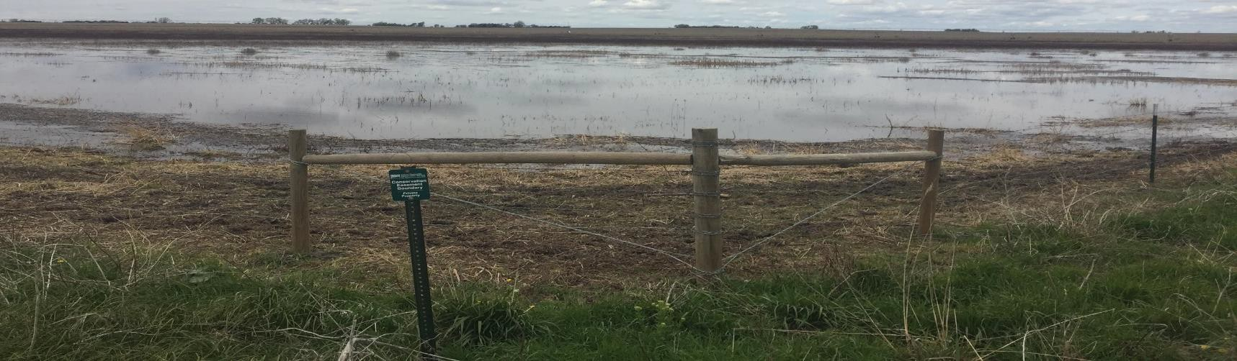

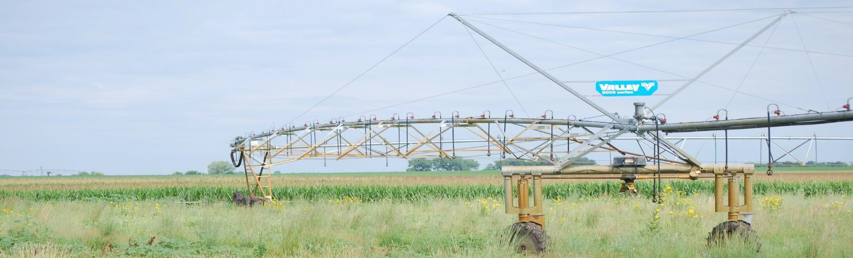

*USDA is an equal opportunity provider, employer, and lender.* Page 2